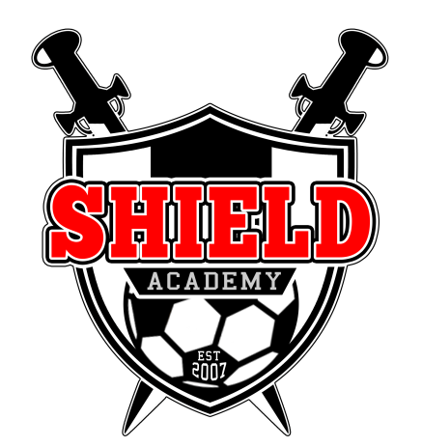

Shield Academy Y/FC
2013/14 Player Registration Form

Basic Details
Age Group (2012/13) | Under
First Name
Last Name
Address
Town/City
County
Postcode

Parent/Guardian’s Details
Parent/Guardian’s Name
Phone Number
Mobile Number
Email Address

Emergency Contacts
Emergency Name
Emergency Number
Relationship to Player

Additional Information
Gender
D.O.B
School
Previous Club
Favoured Positions
Medical Details
Doctor’s Name
Doctors Telephone Number
Any Medical Conditions | Y / N (Please Circle)
If Yes Please Specify

Signed
Signed
Print Name
Date

Parents Code of Conduct
2013/14

- I will do my best to make junior football fun for my child.

- I will use encouragement to help my child to progress and overcome any fear of failure.

- I will encourage good sportsmanship by showing positive support for all players, coaches and officials at every game, training session and other junior sports event.

- I will put the emotional and physical well-being of my child and their team mates ahead of any personal desire to win.

- I will support a sports environment for Shield Academy that is free of illegal drugs, alcohol, cigarettes, abusive language and behaviour that could be seen as offensive, and will from their use at training sessions and games. (Please smoke considerately, well away from the playing area).

- I will ask my child to treat other players, coaches, supporters and officials with respect regardless of race, sex, religion, ability or age.

- I will provide support for coaches and officials working with my child to provide a positive and enjoyable experience for all.

- I will leave any sideline coaching to the Shield Academy team coach assigned to the game/training session.

- I will never argue with, or dispute the referee’s decision, even if the referee makes a mistake.

- I will encourage everyone to use any training or playing facilities or venues, whether Home or Away, properly and respectfully, and to keep them as clean and litter free as possible.

- I will aim to get my child to training and games at the times stated. I will remember to let the Team Rep/Coach know if my child is unavailable A.S.A.P.

- I understand that my child will be registered in a competitive league. I also understand that Shield Academy will try its best to rotate its players, which is recommended to the team managers.

- I understand that my child may be suspended/risk starting matches if they continually miss training (with no contact or reasons), are disruptive to training or games, injured; late arriving at games that have already started, or whose monthly subscriptions have not been paid.

- I understand that for my child to participate in Shield Academy that the team’s subscriptions must be paid in line with the rules set out by the club/team’s management. I accept the consequences if I fail to do this. I also understand that should I decide to leave Shield, I am expected to return my kit and satisfy any outstanding debts.

- I agree to abide by the club’s constitution (See 2013/14 constitution, rule 10), and understand that a failure to do so can affect my child’s membership at Shield Academy.

I accept that if I am welcome to watch training and football matches, however if I break the Parents Code of Conduct the Director of Coaching may inform me that I am not welcome to attend either training or football matches until further notice.

Print Name:

Signature:

Date:

Players Code of Conduct
2013/14

- I will treat everyone at football matches and training with respect and good manners.
- It is an honour to represent Shield Academy and when I am, I shall behave appropriately.
- I will go to as many games and as much training as possible. If I cannot go training or to the game either I or my parents/guardian will get in touch with either the team rep. or the team coach.
- We should all enjoy Shield Academy and will let my parents/guardian and coaches know if I stop enjoying it.
- I will listen to and learn from my coaches.
- Playing football will not interfere with doing my best at school.
- I expect everyone on my team to get a fair amount of playing time
- I will not use illegal substances, cigarettes nor drink alcohol. If I am offered or pressured into using these I will tell my parents, teachers or coaches.
- I will obey the rules of junior football laid down by the FA and any competitive league/s the club is affiliated to.
- I know Shield Academy has a Club Welfare Officer (CWO), and if I have any problems that I cannot share with other adults I know then I can contact the CWO, whose contact details I have been given.

Print Name:

Signature:

Date:

