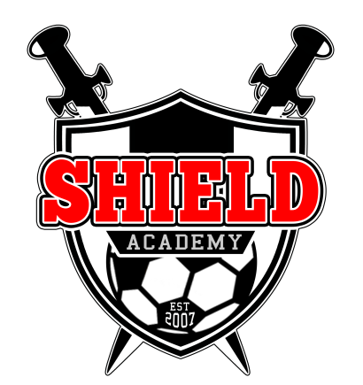
November Newsletter 2013/14
Dear member,
SHIELD ACHIEVES THE FA CHARTER DEVELOPMENT AWARD STATUS:
I am delighted to announce that we have been awarded the FA Charter Development Status by the Football Association.
This has been a long and gruelling process for the club. Personally it has taken long conversations and work alongside the FA, in order to earn this award. It also gave us a great chance to review the structures used by the club, as well as our short and long term plans for the development of the club.
The award takes into account:
- The amount of qualifications held by our coaches, and the level of qualifications.
- The checks carried out on our club staff.
- The management structure of the club and its constitution.
- The club’s development plan.

This is a fantastic milestone for the club, which we are all very delighted with and proud of.
Well done to all of our staff and players for their help in achieving this feat!
Joe Gibson Appointed Club Captain:
We congratulate our Under 18 player, Joe Gibson, who has been appointed as the overall captain of Shield Academy YFC. Joe was the outstanding candidate, who will work with the club in order to fill the gap between players and staff. Additionally Joe will be helping us form a player’s committee.
Player’s Committee:
We are looking at setting up a player’s committee from the various age groups at Shield. Ideally we will be looking at 1 representative per team. The aim of this group will be to meet with the club’s committee in order to help improve the way in which the club runs, giving our players a bigger say in how this happens. We will shortly be contacting our teams in order to begin the voting process.
Keeping the Field Tidy:
Please remember that this is a collective job of everyone at Shield, to ensure that our field is clean and tidy. Can you please remember to bin any rubbish.
Swinging on Goals:
This is becoming an increasing issue, which is extremely dangerous. People swinging on bars risk damaging expensive equipment (which then has to be billed), as well as the risk of serious injury or death. We are against anyone swinging on cross bars, and expect all members of Shield to do their utmost to prevent this from happening.
Under 7’s For Next Season?
If you have a year 1 or 2, why not bring them down on a Saturday Morning. From 10-11am. Price is just £3!
New Coaches:
Want to get into coaching? You could make a real impact! Ring Dan on 07983-552-067
Coach Wants:
U8’s are looking for an assistant coach.
U10 Red’s are looking for an assistant coach.
U12 Whites are looking for a new manager.
Follow Us:
Facebook: Shield Academy FC
Twitter: @ShieldAcademyFC
Website: www.shieldacademy.co.uk

Lastly:
A thank you once more to everyone, including our fantastic management team for their support and putting up with my relentless demands for information, in the build-up to the Charter Development Status. You have all been fantastic!
Dan Seymour; Founder/Director of Football. 07983-552-067.

